RealSense build wrapper from source:

1. Clone: git clone https://github.com/IntelRealSense/RealSenseID.git
2. Mkdir build
3. Cd build
4. cmake .. -DRSID_PY=ON -DRSID_PREVIEW=ON -DCMAKE_BUILD_TYPE=Release
5. cmake --build . --config Release OR goto build and open .sln in visual studio and build rsid_py project

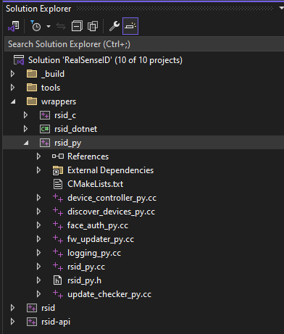

1. Pyd is our python compiled package

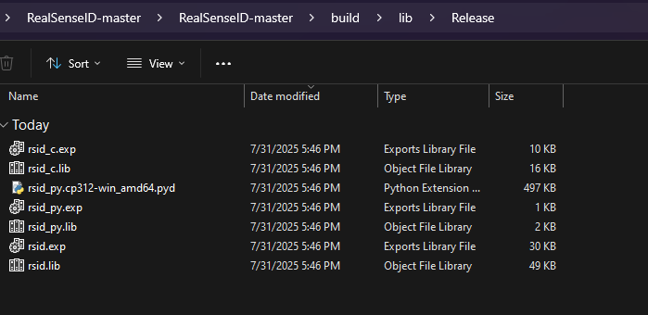

1. manually copy the files into your venv site-packages:

C:\Users\epekerma\Downloads\RealSenseID-master\RealSenseID-master\build\lib\Release\rsid_py.cp312-win_amd64.pyd

Into:

C:\Users\epekerma\...\.venv\Lib\site-packages\

And copy rsid.dll there too.

** if import fails:

import rsid_py

Copy dll and pyd to the folder where you run the script

1. The bindings to pyd are under wrappers/python

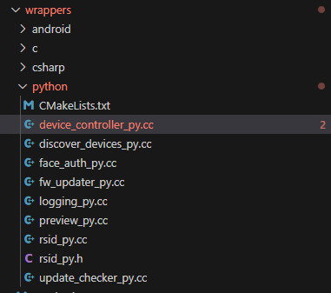

1. Use samples provided in github - Copy the rsid.dll and rsid_py*.pyd (or rsid.so and rsid_py*.so if in Linux) from the build directory to this directory.

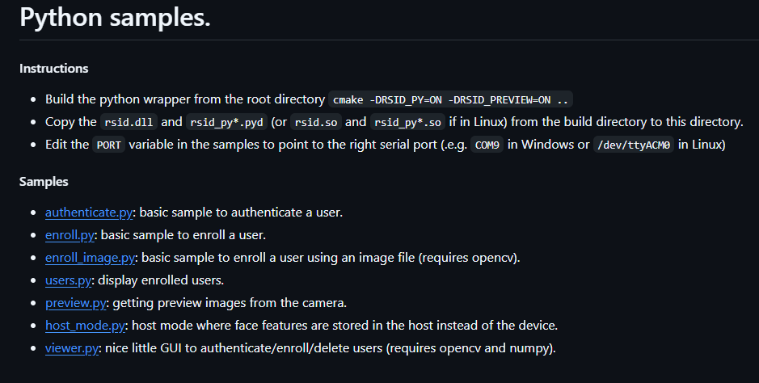

Run:

sudo /home/mahat/Desktop/realsense_stuff/.venv/bin/python viewer_extended.py